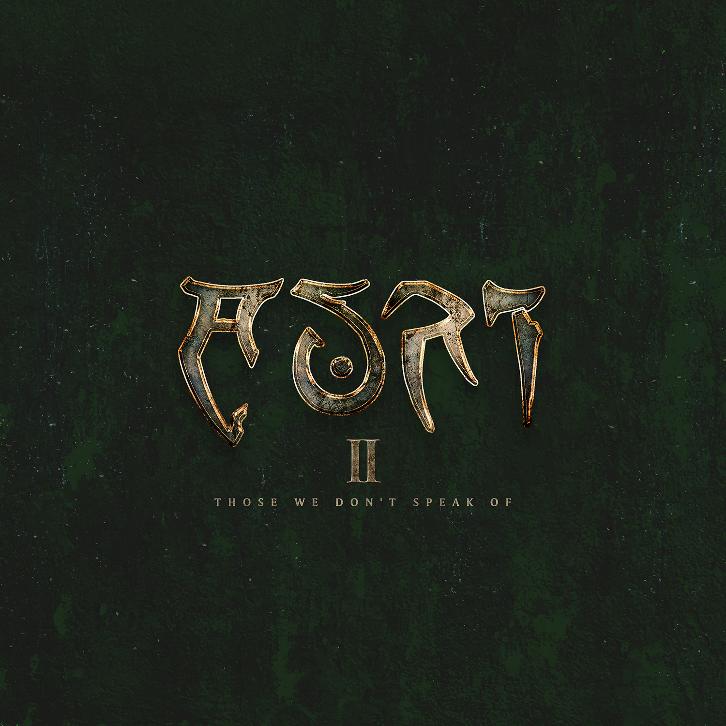

AURI

»II – Those We Don’t Speak Of«

out on September 3rd, 2021

Line-Up: | AURI online:
Johanna Kurkela | voices, violin, viola, keys  Tuomas Holopainen | keys & backing voices  Troy Donockley | guitars, bouzouki, mandola, ulleann pipes, low whistles, aerophone, bodhran, keys, voices | www.facebook.com/AURlband  www.instagram.com/auri.band  www.nuclearblast.de/auri

In the fleeting moments between the state of being awake and reaching the doors of dreamworld lies a borderland whence comes the mood music of ancient stories told – the celestial unison of three creative souls known as AURI.
Originally born in 2011 from the special connection of Johanna Kurkela, Tuomas Holopainen and Troy Donockley, AURI was first introduced to the world as late as 2018. Now complemented by the dynamic percussive talents of Kai Hahto, the threesome carves fantastical worlds entirely their own.

Comprised by Tuomas’ keys and infinite imagination, Troy’s arsenal of flutes, other folk instruments and magical touch, and Kurkela’s youthful and tender voice full of childlike wonder – fragile and gossamer, yet powerful and moving beyond words – the flow of AURI’s celestial, uplifting mood music captures from the first notes and does not let go.

To its key members AURI is a creative outlet unconfined by the preconceptions caused by their other bands and their respective audiences. Leaning to Celtic folk and cinematic pop yet not shackled by any specific genre, AURI isn’t the kind of music that can be described by words alone. No, an equal effort of the enchanted three, AURI runs a lane of completely their own. Unburdened by anyone’s expectations but their own.
This is the sort of music that taps directly into emotions.

Embrace the atmospheric auditory imagery of fantastical valleys of other fairytale dimensions and soon gone fireside bards.
Dwell for just a moment in treasuries of dreamlands and ponderings that see mundane things turning into otherworldly miracles.
Feel welcomed to embark on endless adventures on long roads untrodden and ships never sailed.
As if frozen in time, you’ll be captivated by heart-burstingly elating fare-thee-wells for those dearly departed.
Hear the soft words that empower those feeling inadequate and reassurance to others fearing death.
AURI’s are the keys to a dimension of awe no one else sees. Only theirs to offer are the mystical, soundscapes and ethereal vocals.
Theirs to hold are the magical powers that can melt the steeliest of hearts and make grown men cry.
AURI invites the listener along for journeys no other band can provide.
Come, my love – now it‘s calm enough to go.

